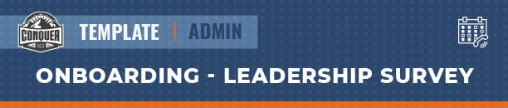

New employees should fill out this survey as part of their onboarding process. Their feedback will help the company put the employee in the best position to develop new leadership qualities and skills.

Have this document available for review during Performance Reviews. It’s smart to have each team member fill out a new one each year, as their growth as leaders progress.

Hello! Welcome to the team. Leadership development is a lifelong process, and [Company] wants to help you grow. Please fill out the survey below. Your answers will help us provide you with growth opportunities that will help you reach your personal and professional goals. Thanks!

-The [Company] Leadership Team

Your Leadership Skills
What are some leadership skills you currently possess? (Examples: project management, problem solving, conflict resolution)

What are some leadership skills you don’t currently have, but would like to develop:

Your Leadership Qualities
What are some leadership qualities you currently possess? (Examples: patience, work ethic, determination)

What are some leadership qualities you don’t currently have, but would like to develop:

Your Future As A Leader
How will developing as a leader help you achieve your future career goals?:

How will developing as a leader help you achieve your future personal goals?:

